Real-Time Bus ID Verification and Tracking

**24-FYP-204**



**Session 2021-2025**

**BACHELOR OF SCIENCE IN** **COMPUTER SCIENCE**

**SUBMITTED BY**

|  |  |
| --- | --- |
| Abubakar Nadeem | 21-NTU-CS-1291 |
| Imran Ali Niaz | 21-NTU-CS-1321 |
| Huzaifa Ahmad | 21-NTU-CS-1318 |

**SUPERVISED BY**

Supervisor: Zahid Javed

Co-Supervisor: Muhammad Naeem

**Department of Computer Science**

**National Textile University, Faisalabad**

# Certification

This is to certify that this project titled “**Real-Time Bus ID Verification and Tracking**” was found to satisfy the requirement for the award of a “**Bachelor of Sciences in Software Engineering**” degree by the Department of Computer Science, National Textile University.

|  |  |
| --- | --- |
| **Supervisor** |  |
| Zahid Javed | ___________________ _____________  Signature Date |
| **Co-Supervisor** |  |
| Muhammad Naeem | ___________________ _____________  Signature Date |
| **External Examiner** |  |
|  | ___________________ _____________  Signature Date |
| **Internal Examiner** |  |
|  | ___________________ _____________  Signature Date |
| **FYP-Convener** |  | |
|  | ___________________ _____________  Signature Date |
| **Head of Department** |  |
| Dr. | ___________________ _____________  Signature Date |

# Declaration

We hereby declared that this document is completely written by us, and it is totally our effort and none of anyone from outside of our group has copied it. This Report is purely written technically in accordance with our project.

**Group Members:**

Abubakar Nadeem ___________________ _____________

21-NTU-CS-1291 Signature Date

E-Mail: abubakaranjum066@gmail.com

Imran Ali Niaz ___________________ _____________

21-NTU-CS-1321 Signature Date

E-Mail: imranaliniaz786@gmail.com

Huzaifa Ahmad ___________________ _____________

21-NTU-CS-1318 Signature Date

E-Mail: huzaifa.ahmad486@gmail.com

**Acknowledgement**

First of all, In the Name of Allah, the Most Beneficent, the Most Merciful. All the praises and thanks be to Allah. A lot of love for our beloved Holy Prophet MUHAMMAD (S.A.W), his guidance always helps us to get the right path. After that, the preparation of this Software Requirements Specification (SRS) document was a collaborative effort involving Abubakar, Imran, and Huzaifa. The author would like to acknowledge and express gratitude to all individuals who directly or indirectly contributed to the completion of this document. Special thanks are extended to our Supervisor Zahid Javed and our Co-Supervisor Muhammad Naeem, who provided invaluable guidance and support throughout the SRS preparation process. The author would also like to acknowledge the invaluable support and suggestions provided by Zahid Javed. This SRS document would not have been possible without the support and cooperation of all involved individuals. The author is confident that this document will serve as a comprehensive guide for the development and implementation of the Real-Time Bus ID Verification and Tracking.

Signed by:

Abubakar Nadeem,

Imran Ali Niaz,

Huzaifa Ahmad,

Date:

00/00/2025

**Abstract**

Efficient and secure transportation is vital for educational institutions, where thousands of students rely on daily commutes. However, current systems face significant challenges, including inefficiencies, security vulnerabilities, and a lack of real-time tracking and communication. Issues such as overcrowding, unauthorized access, and poor resource utilization arise when students board buses without proper verification. Additionally, the absence of real-time bus monitoring and effective communication channels leads to confusion, delays, and suboptimal transport management.

The *Real-Time Bus ID Verification and Tracking* system addresses these challenges by integrating advanced technologies like RFID-based ID verification, live GPS tracking, and automated communication tools. The system ensures only authorized students access transport services, provides real-time visibility of bus locations for students, parents, and administrators, and enables timely updates regarding delays, route changes, or emergencies. It also tracks driver performance, monitors bus occupancy, and generates insights for optimizing route planning and capacity utilization.

By modernizing transport operations, the *Real-Time Bus ID Verification and Tracking* system enhances safety, boosts operational efficiency, and delivers a reliable and user-friendly commuting experience. This solution is an ideal choice for educational institutions aiming to transform their transportation infrastructure with secure and efficient technology.

**Table of Contents**

**Title**  **Page #**

Certification II

Declaration III

List of Abbreviations VIII

CHAPTER 1 1

1 Introduction 1

1.1 Real-Time Bus ID Verification and Tracking System 1

1.2 Reason to Develop 1

1.2.1 Addressing Unique Institutional Needs 2

1.2.2 Enhancing Safety and Security 2

1.2.3 Bridging Communication Gaps 2

1.2.4 Optimizing Resource Management 2

1.2.5 Scalability and Adaptability 2

1.3 Problem Statement 2

1.4 Purpose 3

1.5 Project Goals 3

1.6 Objectives 3

1.7 Project Scope 3

1.8 Proposed Solution 4

1.9 Project Scheduling 4

CHAPTER 2 4

2 Literature Review 4

2.1 Related Work 4

2.1.1 Tyler Technologies’ Student Transportation Software 5

2.1.2 Edulog 5

2.1.3 Loqqat 5

2.2 RFID Technology in Transportation Systems 5

2.3 GPS-Based Bus Tracking 6

2.4 Load Management in Public Transportation 6

2.5 Predictive Arrival Systems 6

2.6 Mapping APIs: Google Maps and Map box 6

2.6.1 Google Maps API 6

2.6.2 Map box 7

CHAPTER 3 7

3 System Requirements 7

3.1 Functional Requirements 7

3.1.1 User Authentication and Authorization: 7

3.1.2 Bus and Route Management 7

3.1.3 Journey Management 7

3.1.4 Bus Card Management 8

3.1.5 Session and Student Management 8

3.1.6 Bus Staff Management 8

3.1.7 Complaint Management 8

3.1.8 Announcement Management 8

3.1.9 Notification and Alerts 8

3.1.10 Live Location Tracking 8

3.2 Non-Functional Requirements 9

3.2.1 Security: 9

3.2.2 Performance 9

3.2.3 Availability: 9

3.2.4 Scalability: 9

3.2.5 Usability: 9

3.2.6 Maintainability: 9

3.2.7 Efficiency 9

3.3 Use Case Diagram 9

3.3.1 Use Case of Sign In 10

3.3.2 Use Case of Sign Up 10

3.3.3 Use Case of Bus and Route Management 11

3.3.4 Use Case of Journey Management 12

3.3.5 Use Case of Bus card Management 12

3.3.6 Use Case of Student & Session Management 13

3.3.7 Use Case of Bus Staff Management 13

3.3.8 Use Case of Complaint Management 14

3.3.9 Use Case of Announcement Management 14

3.3.10 Use Case of General Functionalities 15

3.3.11 Use Case of Complete System 16

3.4 Use Case Description. 16

3.4.1 Description of Sign In: 16

3.4.2 Description of Sign Up: 17

3.4.3 Description of Bus and Route Management: 17

3.4.4 Description of Journey Management: 18

3.4.5 Description of Bus Card Management: 18

3.4.6 Description of Session and Student Management: 19

3.4.7 Description of Bus Staff Management: 20

3.4.8 Description of Complaint Management: 20

3.4.9 Description of Announcement Management: 21

3.4.10 Description of General Functionalities: 21

Chapter 4 22

4.1 Agile Software Development Methodology 22

4.2 Selected Methodology: Agile 22

4.3 Reasons for Selecting Agile Methodology 22

4.4 Agile Project Planning and Execution for RT-BIVT 23

# List of Abbreviations

|  |  |
| --- | --- |
| RT-BIVT | Real-Time Bus ID Verification and Tracking |
| RFID | Radio Frequency Identification |
| RT-BIVT system | Admin Panel, Driver and Student App’s |
|  |  |
|  |  |

# CHAPTER 1

# Introduction

Efficient and secure transportation systems are crucial for educational institutions of all sizes, where thousands of students rely on daily commutes. However, many institutions face significant challenges, including inefficiencies, security vulnerabilities, and a lack of real-time tracking and communication. Students often board buses without proper verification, leading to overcrowding, unauthorized access, and inequitable usage of transport resources. Additionally, the absence of real-time monitoring for buses and driver performance, coupled with ineffective communication channels, results in confusion, delays, and poor management of transport operations.

To address these challenges, we propose a **RT-BIVT** system tailored for educational institutions. This system combines advanced technologies like **RFID**-based ID verification, live **GPS** tracking, and automated communication tools to streamline transportation management. It ensures that only authorized students access transportation services, provides real-time visibility of bus locations for students, parents, and administrators, and facilitates timely updates on delays, route changes, or emergencies. Additionally, the system tracks driver performance, monitors bus occupancy, and generates alerts to optimize route planning and capacity utilization.

This innovative solution goes beyond solving existing challenges—it transforms transportation management into a secure, efficient, and user-friendly ecosystem. By integrating modern technologies, the **RT-BIVT** system enhances safety, improves operational efficiency, and delivers a reliable transportation experience, making it an ideal choice for any educational institution seeking to modernize its transport infrastructure.

## Real-Time Bus ID Verification and Tracking System

The **RT-BIVT** system is an innovative solution designed to enhance transportation efficiency and safety for educational institutions. It integrates cutting-edge technologies like **RFID** for ID verification, live **GPS** tracking, and an advanced communication framework to create a streamlined, user-friendly transportation management ecosystem. This system empowers institutions to optimize bus routes, manage capacity, and monitor driver performance, ensuring a secure and efficient transport experience for students, parents, and administrators.

## Reason to Develop

The development of the RT-BIVT system is driven by several compelling factors, despite the existence of other transportation solutions:

### Addressing Unique Institutional Needs

Educational institutions often face specific challenges like unauthorized access, overcrowding, and inefficient communication. Generic transport management systems fail to meet these tailored needs, prompting the creation of a solution that directly addresses the unique requirements of such environments.

### Enhancing Safety and Security

Ensuring that only authorized students use transport facilities is crucial for security and fairness. RFID-based verification provides a reliable, real-time solution to mitigate misuse and enhance safety for students and drivers.

### Bridging Communication Gaps

A lack of effective communication between transport departments, parents, and students leads to confusion and inefficiency. The proposed system integrates real-time notifications for updates like delays, route changes, and emergencies, ensuring timely and clear communication.

### Optimizing Resource Management

Overcrowding or underutilization of buses is a common issue. By integrating occupancy monitoring and route optimization, this system helps administrators allocate resources more efficiently, reducing costs and enhancing comfort.

### Scalability and Adaptability

The system is designed to adapt to the specific challenges of any educational institution, whether managing a small fleet or a large-scale transport network. It is scalable, ensuring that institutions can continue to benefit as their transportation needs evolve.

This project is more than a technological upgrade; it is a strategic initiative to modernize transport systems, improve safety, and deliver a seamless experience for all stakeholders in an educational environment.

## Problem Statement

Educational institutions face significant challenges in managing their transportation systems effectively. Common issues include overcrowded or underutilized buses, unauthorized access, inefficient communication, and a lack of real-time tracking. These problems result in confusion, operational inefficiencies, and safety concerns for students, parents, and administrators. Existing solutions often lack the integration and adaptability required to address these specific institutional needs.

## Purpose

The primary purpose of the RT-BIVT system is to provide a seamless, all-in-one solution for transportation management in educational institutions. By combining secure access verification, live GPS tracking, and advanced communication tools, the system aims to improve operational efficiency, enhance student safety, and streamline communication among all stakeholders.

## Project Goals

* Implement secure ID verification to prevent unauthorized access.
* Provide live bus location tracking for real-time visibility and improved coordination.
* Enable real-time notifications for updates such as delays, route changes, or emergencies.
* Track key metrics like speed, stop intervals, and adherence to schedules.
* Streamline bus scheduling, capacity management, and route planning.
* Ensure an intuitive interface for administrators, parents, and students.

## Objectives

Objectives of the project are as follows:

* Integrate RFID-based ID verification to ensure only authorized users board the buses.
* Provide GPS-enabled tracking for buses accessible to students, parents, and administrators.
* Enable alerts for overcrowding or underutilization to optimize bus capacity.
* Monitor driver behaviour to ensure adherence to safety and efficiency standards.
* Develop a mobile app for notifications and updates to keep all stakeholders informed.

## Project Scope

Although designed for educational institutions, this system can be extended to other domains such as corporate transport, public transit, or private bus fleets. Its modular design allows for customization and scalability, making it suitable for varying transportation requirements and operational complexities.

## Proposed Solution

The system offers a modular and comprehensive approach to transportation management. It features real-time ID verification using **RFID**, live **GPS** tracking for buses, occupancy alerts, driver performance monitoring, and mobile apps for seamless communication. By adopting this system, institutions can significantly enhance operational efficiency, reduce resource wastage, and ensure a safer, more reliable transport experience for all users.

## Project Scheduling

Here is the Gantt chart for the RT-BIVT project. This chart visually represents the project timeline, including the start and end dates for each activity. It provides a high-level overview of how the project tasks are scheduled over time, aiding in effective project management and tracking. The timeline of the project is shown by the Gantt chart in Figure 1.1.

*Figure 1.1 Gantt Chart*

**CHAPTER 2**

1. **Literature Review**

RT-BIVT system aims to enhance transportation services for students and parents by integrating technologies such as RFID scanning, GPS tracking, real-time data analytics, and mapping services. This chapter reviews existing literature and technologies pertinent to the project, including RFID technology in transportation systems, GPS-based bus tracking, load management in public transportation, predictive arrival systems, and the utilization of mapping APIs like Google Maps and Map box. Additionally, it examines existing student transportation management systems to identify current solutions and gaps.

* 1. **Related Work**

Several transportation management systems cater to student transit needs, offering features like GPS tracking, route optimization, and parent communication. Notable examples include:

### Tyler Technologies’ Student Transportation Software

Provides integrated solutions for bus routing, fleet maintenance, and parent communication, connecting various aspects of transportation management.

Cons:

* High implementation and licensing costs for smaller institutions.
* Steep learning curve for administrators unfamiliar with the software.
* Limited customization options for unique institutional requirements.

[Tyler Technologies](https://www.tylertech.com/products/student-transportation?utm_source=chatgpt.com)

### Edulog

Combines school bus routing, GPS fleet tracking, student ridership management, and parent communication apps into a single platform, aiming to streamline transportation operations.

Cons:

* Complex setup and configuration for multi-campus institutions.
* Frequent updates are causing temporary compatibility issues.
* Limited integration with non-standard hardware or legacy systems.

[Edulog](https://www.edulog.com/?utm_source=chatgpt.com)

### Loqqat

Provides a smart real-time school bus tracker and management software, enabling route scheduling and live tracking to ensure student safety.

Cons:

* Narrow focus on live tracking, lacking advanced features like fleet maintenance.
* Limited scalability for large institutions with extensive fleets.
* Higher costs for adding additional features beyond basic tracking.

[Loqqat](https://loqqat.com/?utm_source=chatgpt.com)

## RFID Technology in Transportation Systems

Radio Frequency Identification (RFID) is extensively used in transportation for access control and user validation. Embedding RFID tags in student cards facilitates automated scanning and validation, ensuring user authenticity. Studies highlight RFID’s reliability, speed, and accuracy in real-time scenarios, making it suitable for monitoring passenger eligibility in bus systems.

In UBMS, RFID technology plays a crucial role in validating fee payment and ensuring time-based scanning, which enhances security and prevents misuse. The integration of RFID with time constraints ensures compliance and builds trust among stakeholders.

## GPS-Based Bus Tracking

GPS technology has transformed public transportation by enabling real-time vehicle tracking. It allows passengers and administrators to monitor bus locations, enhancing operational transparency and service quality. Research shows that GPS tracking improves user satisfaction by providing accurate location updates and estimated arrival times (ETA).

In RT-BIVT, GPS tracking enables parents and students to plan their journeys effectively. Combined with predictive algorithms, GPS data ensures accurate ETAs and facilitates driver accountability. It also provides valuable data for optimizing bus routes and schedules.

## Load Management in Public Transportation

Load management is critical in public transportation, as overloading can lead to safety concerns and underutilization can cause inefficiencies. Techniques such as weight sensors and real-time passenger counting are effective for monitoring bus capacity.

RT-BIVT incorporates real-time load analysis to ensure passenger safety and optimize bus fleet utilization. By combining load data with historical patterns, the system can predict demand and adjust operations accordingly.

## Predictive Arrival Systems

Predictive arrival systems leverage GPS data, traffic patterns, and historical records to provide accurate ETAs. Studies indicate that such systems enhance user trust and satisfaction. The integration of machine learning algorithms can further improve prediction accuracy.

In RT-BIVT, predictive arrival features reduce waiting times and improve convenience for students and parents. These features, presented through intuitive interfaces, contribute to a positive user experience.

## Mapping APIs: Google Maps and Map box

Mapping services are integral to transportation management systems, providing visualization and geolocation functionalities.

### Google Maps API

Google Maps API is a comprehensive mapping solution offering features such as real-time traffic data, route planning, and ETA calculations. Its extensive database and reliability make it a popular choice for developers. In RT-BIVT, Google Maps API plays a vital role in calculating ETAs.

### Map box

Map box is a customizable map SDK that enables developers to design tailored map experiences. It offers dynamic theming, offline maps, and robust integration capabilities. Map box’s flexibility and performance make it suitable for applications requiring specialized mapping solutions. For RT-BIVT, Map box provides an opportunity to create branded, intuitive interfaces for users.

The choice between Google Maps API and Map box depends on project requirements, budget, and desired user experience. Both solutions are integral to building reliable transportation systems.

**CHAPTER 3**

1. **System Requirements**

In this bankruptcy, all of the useful requirements of the application and the overall requirement of the stockholders are documented as it’s an important a part of a mission or product that allows to satisfy stakeholder’s necessities. Now, we can speak system necessities, practical necessities, software program development, and present and selected methodology with the purpose of technique. These sections describe software program methodologies which are present and decided on for this assignment with the glide of machine and alertness detail depicted.

## Functional Requirements

### User Authentication and Authorization:

The system must support multiple user roles (e.g., Super Admin, Admin, Driver, Conductor, and Student) and implement secure login functionality based on valid credentials. It must include a module for creating user accounts, assigning roles, and enforcing role-based access control to ensure users can access only the modules they are authorized to use.

### Bus and Route Management

The Admin must be able to manage bus details and define territories or routes for buses. The Driver must be able to record and update routes for specific buses. Additionally, the Admin must have the ability to view the list of available buses and their assigned routes.

### Journey Management

The Driver must be able to initiate or end a journey, with the system tracking the live location of buses during active journeys. The Driver is responsible for authenticating student cards when they board the bus, and the system must record journey data, including the bus number, route, boarded students, and the driver. Both Admin and Students must have access to the bus’s live location, while Admin also be able to view the complete journey history for all buses.

### Bus Card Management

The admin must be able to assign bus cards to students, as well as revoke or enable student bus cards as needed. The system must also verify student bus cards during boarding to ensure proper access.

### Session and Student Management

The system must allow the Admin to create and end user sessions, as well as set their expiry dates. It should automatically disable student cards when a session expires or is deleted. Additionally, the system must generate app credentials for students upon their addition to the system.

### Bus Staff Management

Admin must be able to add and manage Drivers and Conductors within the system. Upon registration, the system must generate app credentials for these staff members to enable secure access and management of their duties.

### Complaint Management

Students and Drivers must have the ability to submit complaints through their apps. Admin should have a module to view, address, and resolve these complaints, and the system must maintain a record of all complaints along with their current statuses.

### Announcement Management

Admin must be able to create and manage announcements within the system. Announcements must be delivered as notifications to Drivers and Students through their apps to ensure timely updates.

### Notification and Alerts

The system must send notifications to Students and Drivers regarding announcements, route updates, and other relevant information. Additionally, the system must alert Admin if a bus deviates from its assigned route or leaves its designated area.

### Live Location Tracking

The system must track and display the real-time location of buses during active journeys. Both Admin and Students should be able to access this live location data via their apps, and the system must store location data for journey history and analysis purposes.

* 1. **Non-Functional Requirements**

### Security:

Implement robust authentication and authorization checks.

### Performance

The system should respond to user actions promptly.

### Availability:

The system should be available 24/7.

### Scalability:

The system must be scalable to handle an increasing number of users and data.

### Usability:

User interface should be intuitive and easy to navigate.

### Maintainability:

The system should be easy to maintain and update with minimal downtime.

### Efficiency

The system should optimize resource usage and minimize latency during operations.

## Use Case Diagram

For graphical visualization of actor interaction with the components of the systems, the most appropriate approach is to use case diagrams that graphically represent which actor may perform or access which functionality or component of the system.

### Use Case of Sign In

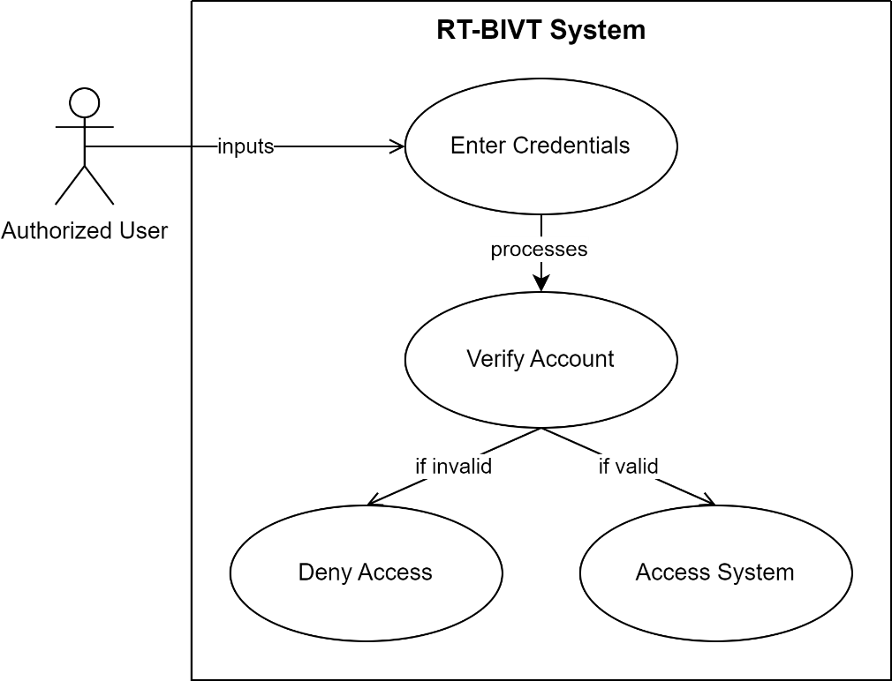

*Figure 3.3.1 Use Case of Sign In*

### Use Case of Sign Up

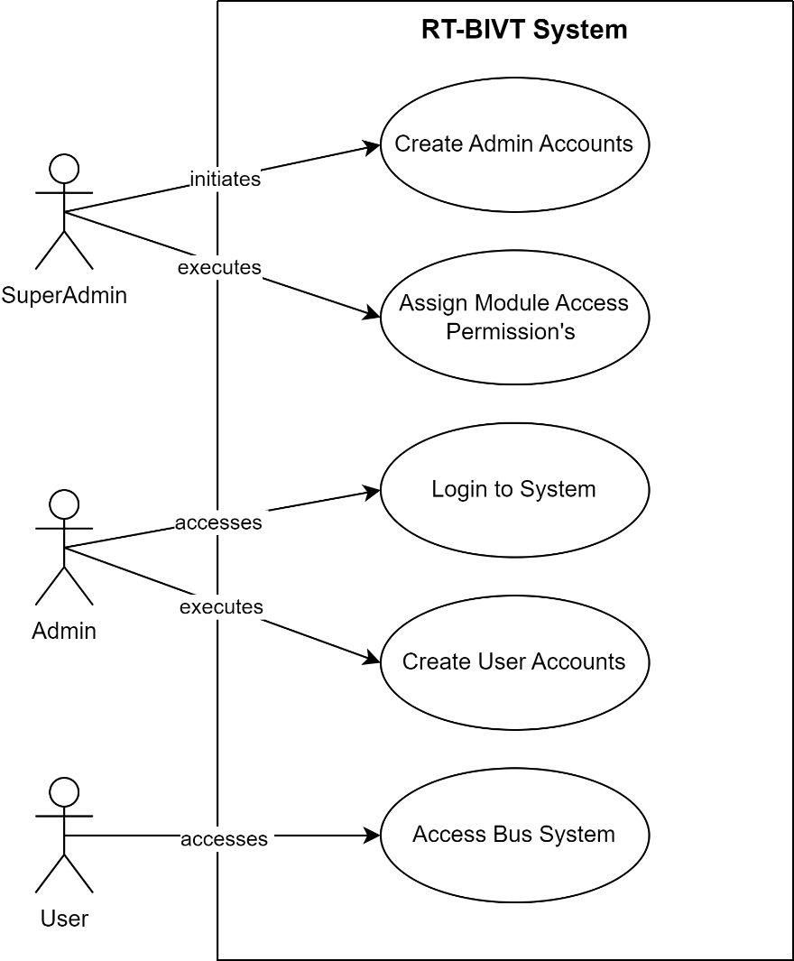

*Figure 3.3.2 Use Case of Sign Up*

### Use Case of Bus and Route Management

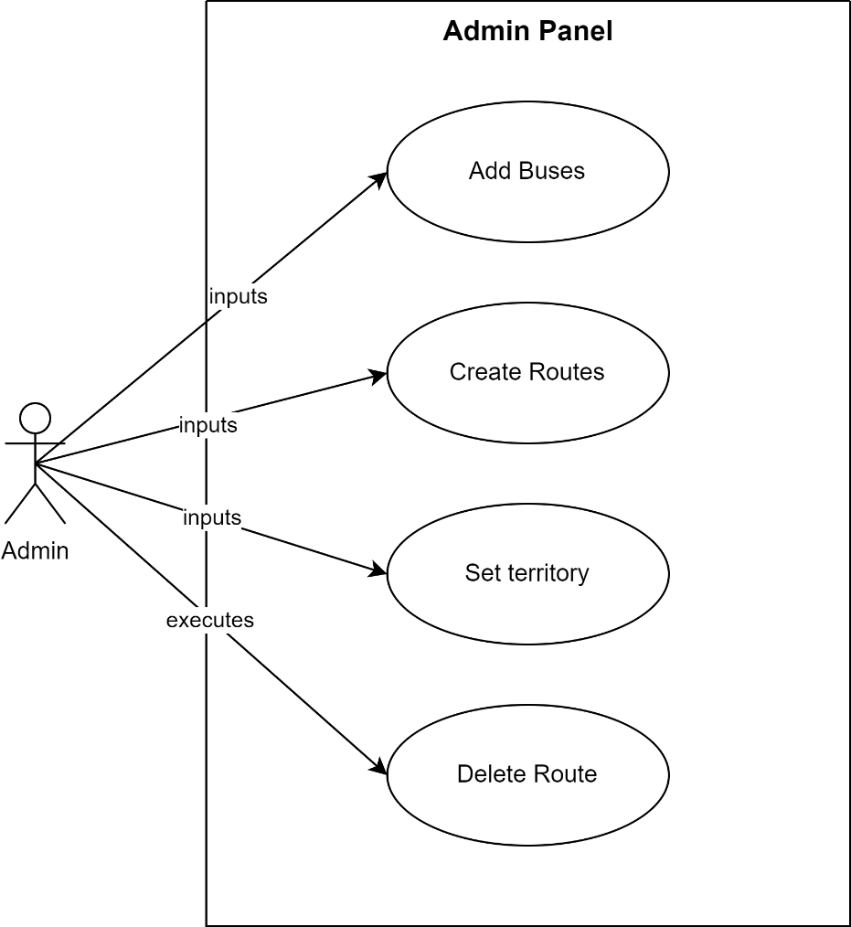

*Figure 3.3.3 Use Case of Bus and Route Management*

### Use Case of Journey Management

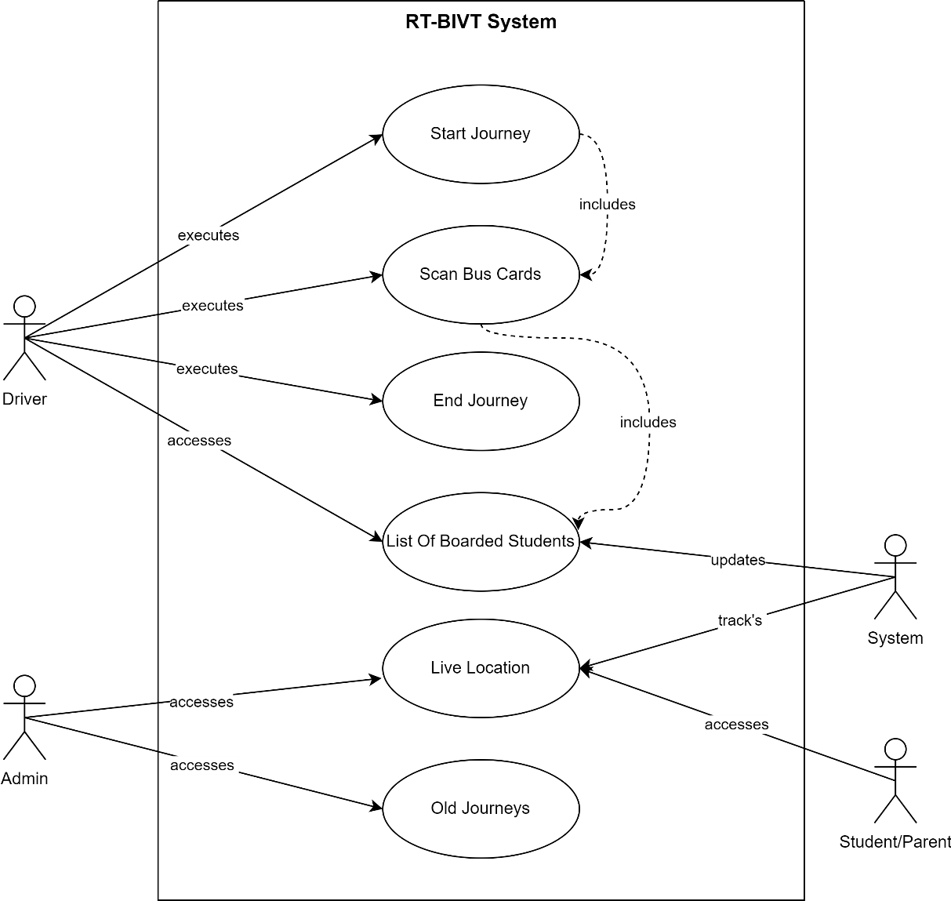*Figure 3.3.4 Use Case of Journey Management*

### Use Case of Bus card Management

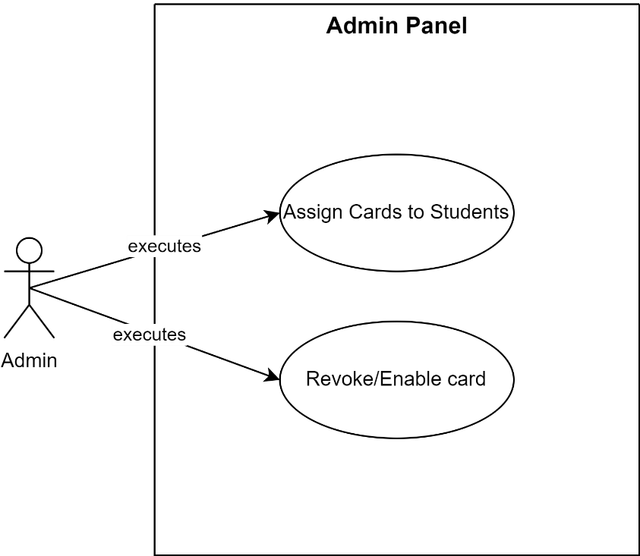

*Figure 3.3.5 Use Case of Bus Card Management*

### Use Case of Student & Session Management

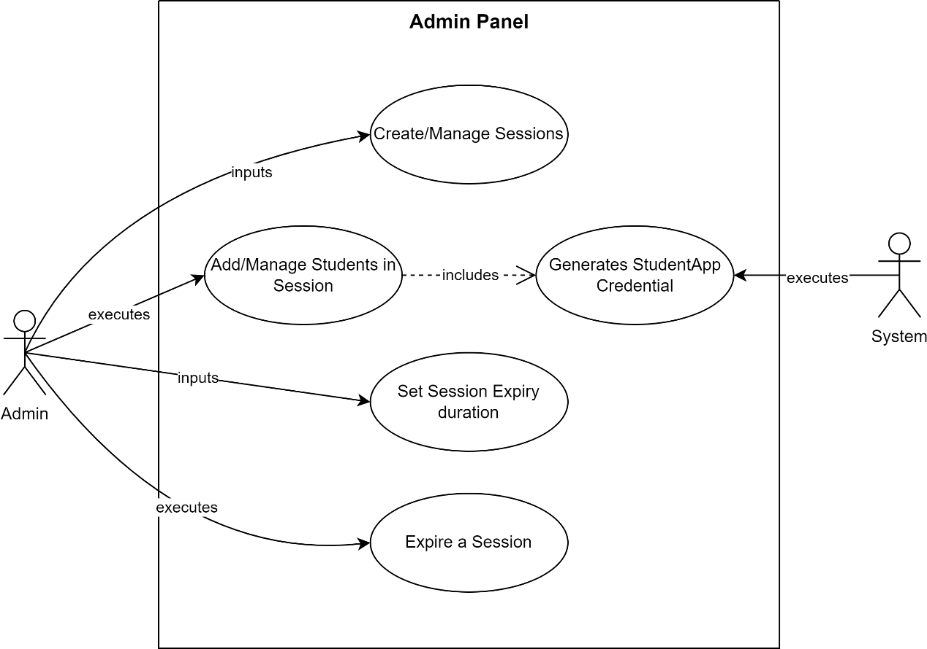

*Figure 3.3.6 Use Case of Student & Session Management*

### Use Case of Bus Staff Management

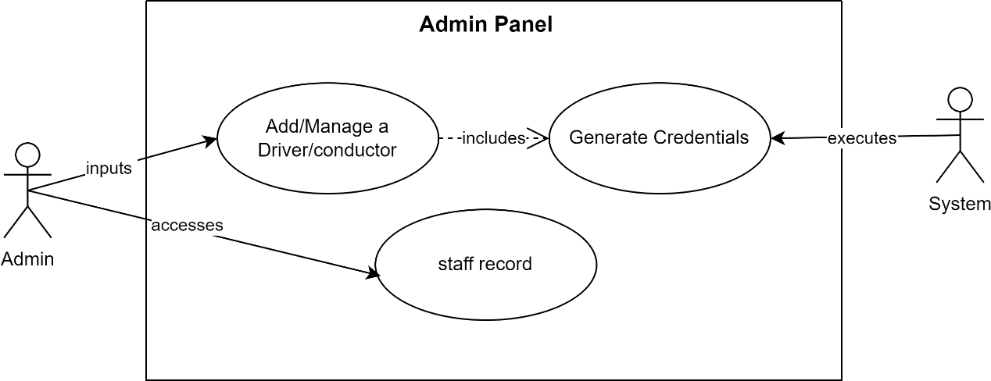

*Figure 3.3.7 Use Case of Bus Staff Management*

### Use Case of Complaint Management

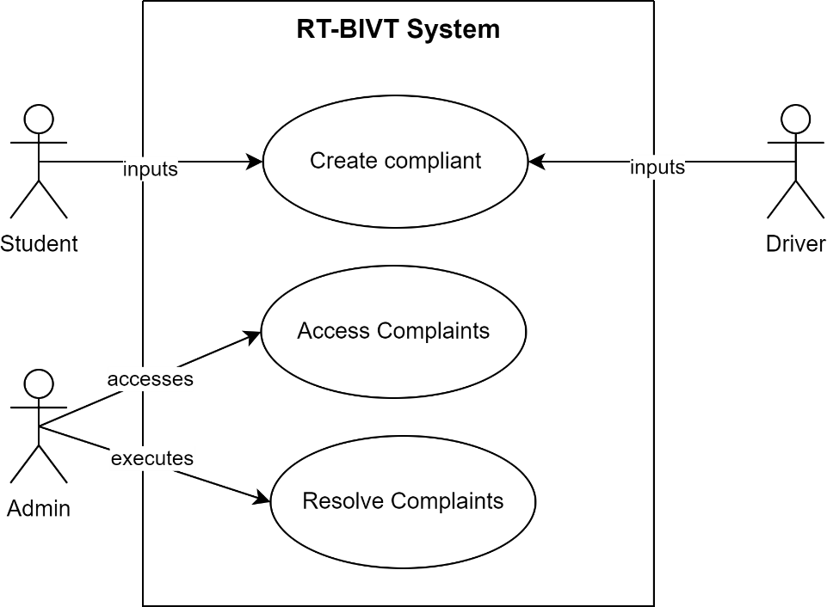

*Figure 3.3.8 Use Case of Complaint Management*

### Use Case of Announcement Management

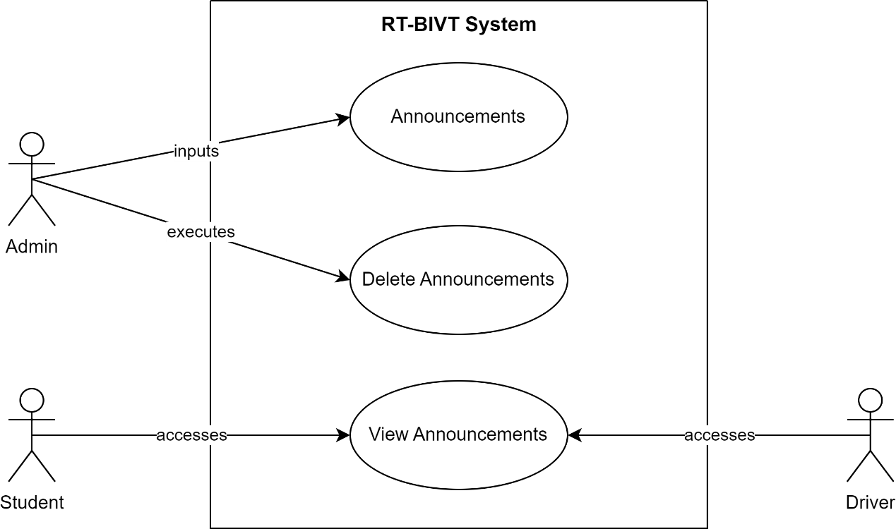

*Figure 3.3.9 Use Case of Announcement Management*

### Use Case of General Functionalities

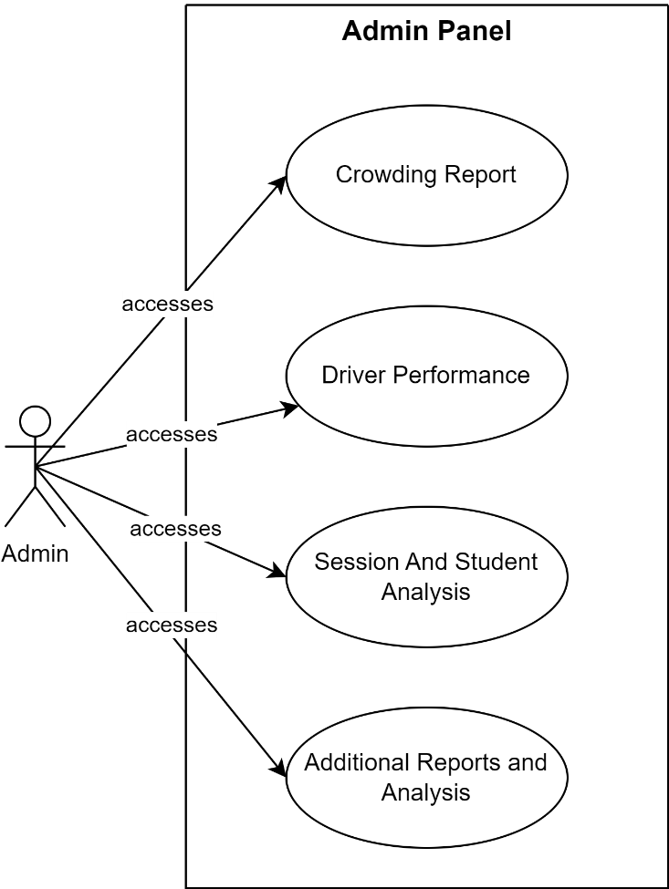

*Figure 3.3.10 Use Case of General Functionalities*

### Use Case of Complete System

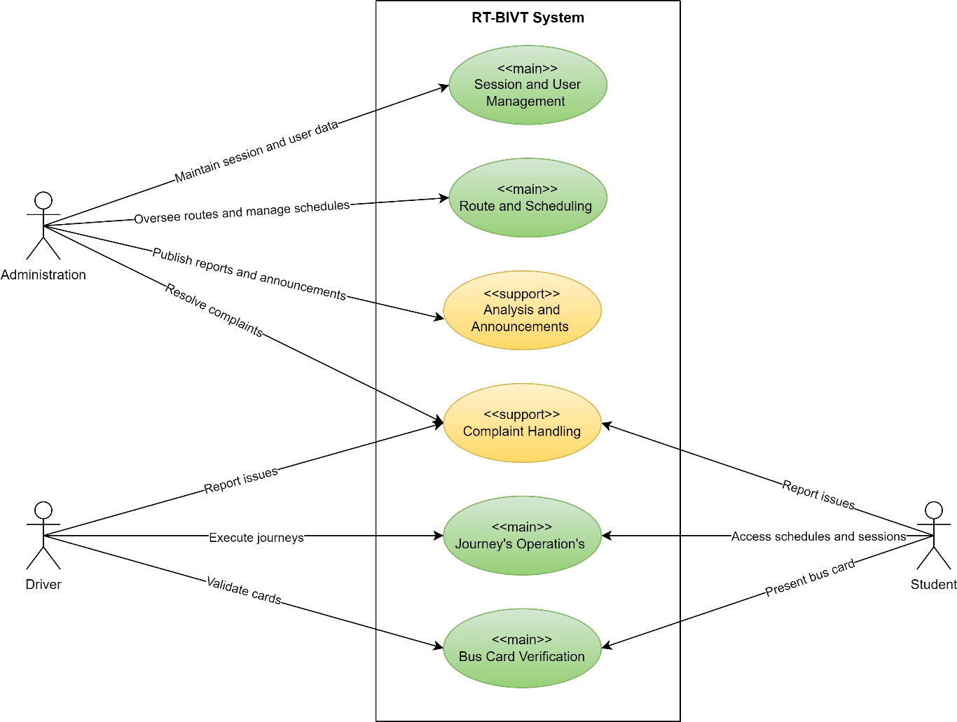

*Figure 3.3.11 Use Case of Complete System*

## Use Case Description.

Use case description contains every piece of information (use case id, use case name, description, pre- and post-conditions) of each use case.

### Description of Sign In:

|  |  |
| --- | --- |
| Field | Details |
| Use Case Id | 01 |
| Use Case Name | Sign In |
| Actors | Authorized User |
| Description | Authorized users log in to the RT-BIVT via provided applications. Access is denied if the user does not have an account or proper credentials. |
| Pre-condition | User must have an account and credentials. |
| Post-condition | User logs into the RT-BIVT system or is denied access. |

*Table: 3.4.1 Description of Sign In*

### Description of Sign Up:

|  |  |
| --- | --- |
| Field | Details |
| Use Case Id | 02 |
| Use Case Name | Sign Up |
| Actors | Super Admin, Authorized User |
| Description | A Super Admin has the ability to create admins and assign specific roles and permissions to each. These admins are tasked with managing the creation of user accounts, including those for bus staff and students. |
| Pre-condition | User must have an account, enough permissions and credentials to access system. |
| Post-condition | A new user is created with specific roles and permissions to operate with in RT-BIVT. |

*Table: 3.4.2 Description of Sign Up*

### Description of Bus and Route Management:

*Table: 3.4.3 Description of Bus and Route Management*

|  |  |
| --- | --- |
| Field | Details |
| Use Case Id | 03 |
| Use Case Name | Bus and Route Management |
| Actors | Admin |
| Description | The admin is responsible for adding buses, defining routes, and assigning territories. |
| Pre-condition | Admin must be authenticated and have enough permissions to manage buses and routes. |
| Post-condition | The admin effectively oversees the management of buses, routes, and territories. |

### Description of Journey Management:

*Table: 3.4.4 Description of Journey Management*

|  |  |
| --- | --- |
| Field | Details |
| Use Case Id | 04 |
| Use Case Name | Journey Management |
| Actors | Admin, Driver, Student |
| Description | The driver starts and ends journeys while verifying student bus cards during the trip. The system logs journey-related data and tracks the bus's live location, enabling administration, students, and parents to access journey details and monitor the bus's real-time location. |
| Pre-condition | The driver must be authenticated and have specified the route and the bus they are assigned to. The student must possess a valid and active bus card. |
| Post-condition | The driver successfully operates the journeys, while the system tracks and updates the journey details and live bus location. This allows both administrators and students/parents to access the journey information and the live location of the bus. |

### Description of Bus Card Management:

*Table: 3.4.5 Description of Bus Card Management*

|  |  |
| --- | --- |
| Field | Details |
| Use Case Id | 05 |
| Use Case Name | Bus Card Management |
| Actors | Admin |
| Description | The admin is responsible for assigning and managing student bus cards. |
| Pre-condition | The admin must be authenticated and have necessary permissions to manage bus cards. Students are required to be registered in the system. |
| Post-condition | The admin can successfully assign bus cards to students, revoke the cards to prevent further use, and re-enable them when needed. |

### Description of Session and Student Management:

*Table: 3.4.6 Description of Session and Student Management*

|  |  |
| --- | --- |
| Field | Details |
| Use Case Id | 06 |
| Use Case Name | Session and Student Management |
| Actors | Admin, System |
| Description | The admin can create and terminate sessions, set session expiry, and manage students within the system. When a student is added, the system automatically generates app credentials for them. Expiring or deleting a session will deactivate all bus cards associated with that session. |
| Pre-condition | The admin must be authenticated and have necessary permissions to manage bus cards. Student data must be accurate and complete for the generation of credentials. |
| Post-condition | The admin effectively oversees both sessions and student management. |

### Description of Bus Staff Management:

*Table: 3.4.7 Description of Bus Staff Management*

|  |  |
| --- | --- |
| Field | Details |
| Use Case Id | 07 |
| Use Case Name | Bus Staff Management |
| Actors | Admin, System |
| Description | The admin oversees drivers and conductors. When a new staff member is added, the system automatically generates app credentials for them. |
| Pre-condition | The admin must be authenticated and have necessary permissions to manage bus staff. |
| Post-condition | The admin effectively manages bus staff. |

### Description of Complaint Management:

|  |  |
| --- | --- |
| Field | Details |
| Use Case Id | 08 |
| Use Case Name | Complaint Management |
| Actors | Student, Driver, Admin |
| Description | Students and drivers are allowed to submit complaints about transportation services and related concerns. |
| Pre-condition | All users are required to be authenticated. Administrators must also be authenticated and possess the necessary permissions to manage complaints. |
| Post-condition | Complaints submitted by students and drivers get reviewed and resolved by the authorities. |

*Table: 3.4.8 Description of Complaint Management*

### Description of Announcement Management:

*Table: 3.4.9 Description of Announcement Management*

|  |  |
| --- | --- |
| Field | Details |
| Use Case Id | 09 |
| Use Case Name | Announcement Management |
| Actors | Admin, Driver, Student |
| Description | The admin shares announcements related to transportation. |
| Pre-condition | All users are required to be authenticated. |
| Post-condition | The administrator successfully posts announcements. |

### Description of General Functionalities:

*Table: 3.4.10 Description of General Functionalities*

|  |  |
| --- | --- |
| Field | Details |
| Use Case Id | 10 |
| Use Case Name | General Functionalities |
| Actors | Users |
| Description | The admin can generate reports and analyse valuable information extracted from the data currently stored. |
| Pre-condition | The admin must be authenticated and have necessary permissions. |
| Post-condition | Administration makes better decisions and enhances services through the analysis of current transportation data. |

# Chapter 4

## 4.1 Agile Software Development Methodology

Agile methodology is an iterative and incremental approach to software development that emphasizes flexibility, collaboration, and customer feedback. Unlike traditional methodologies like the Waterfall model, Agile allows for adaptive planning, evolutionary development, and continual improvement, enabling rapid and flexible responses to change. It is particularly effective in managing the complexity and unpredictability of software projects.

## 4.2 Selected Methodology: Agile

A software development methodology is a way to improve development work with the help of dividing the development process into distinct phases to make a system with better productivity. It also helps to structure and control the whole system. It involves different methodologies, also called the Software Development Life Cycle, that are stages for software development with a certain set of rules. Generically, we categorized the methodologies into Rapid application development and planned-driven. Waterfall, spiral is planned driven while agile is Rad based.

## 4.3 Reasons for Selecting Agile Methodology

1. **Flexibility and Adaptability**: Agile allows the project to adapt to changes in requirements and technology swiftly.
2. **Customer Collaboration**: Regular feedback from users ensures that the development aligns with the user's needs and expectations.
3. **Incremental Delivery**: Agile facilitates the delivery of small, workable segments of the project, ensuring a faster time-to-market and continuous improvement.
4. **Risk Management**: Regular reviews and iterations help in early identification and resolution of issues, reducing the overall risk.

## 4.4 Agile Project Planning and Execution for RT-BIVT

Agile project planning and execution involve the division of the project into sprints, with each sprint aimed at delivering a potentially shippable product increment. The key phases include:

1. **Product Backlog Creation**: Gather and prioritize necessities for the RT-BIVT undertaking, growing a product backlog.
2. **Sprint Planning**: At the start of every dash, pick a hard and fast of capabilities from the product backlog and plan their delivery.
3. **Daily Stand-ups**: Conduct day by day meetings to speak about development, demanding situations, and plan the day's paintings.
4. **Sprint Execution**: Develop, take a look at, and combine features inside the dash.
5. **Sprint Review**: At the quilt of every sprint, reveal the finished paintings to stakeholders and collect comments.
6. **Sprint Retrospective**: Reflect at the sprint to identify successes and regions for development.
7. **Release Planning**: Plan releases based totally at the undertaking progress, stakeholder comments, and marketplace situations.

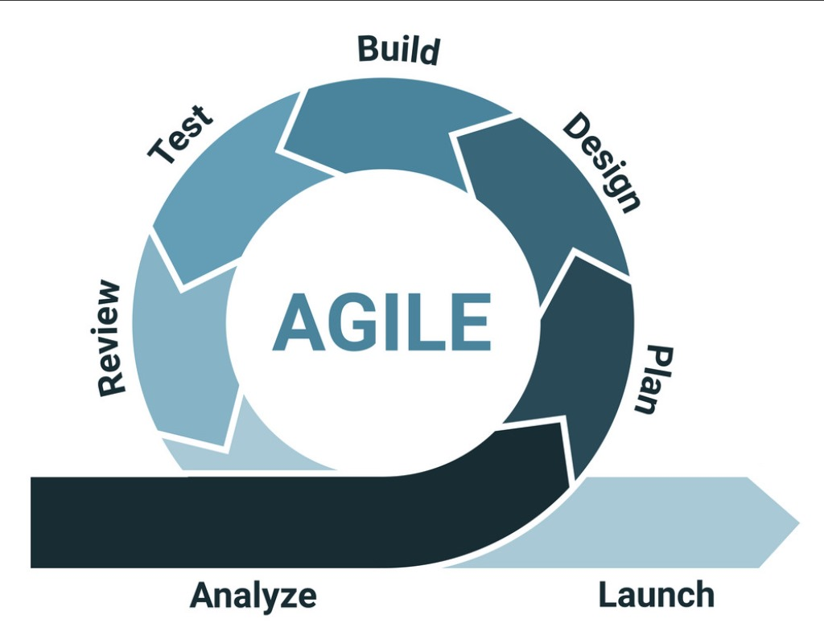

*Figure 4.2 Agile Model*